Experiment-9

Views

1.Create a table student with attributes studno,name,dept

2.display



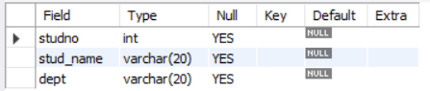

3.Create view and select



4.insert values

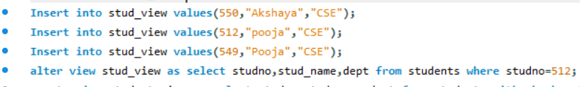

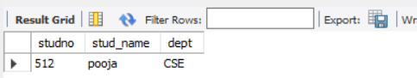

5.Create view with check option

Insert values and alter table

